Sync Jobs
Purpose: To Sync the PLUG IN (S4HANA/ECC) system data into GRC system. The ECC data is not created in GRC system but it is stored in GRAC* tables of GRC system with reference to Plug-in system name.
Tables:
GRACRLCONN – Roles in Backend System
GRACUSERCONN – Users in Backend System
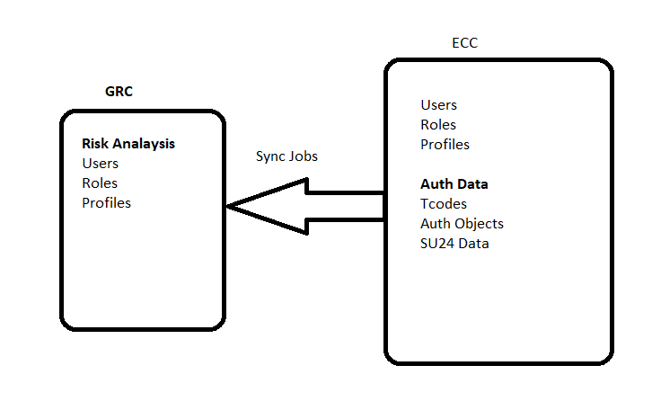
Path for Sync Jobs: SPRO ------ > IMG Reference ------- > GRC ------> Access Control ----- > Sync Jobs
Types of Sync Jobs:
- Authorization Sync: Used to sync Auth Data like T-codes, Auth Objects and SU24 Data. This job is not required for JAVA systems & NON SAP Systems.
- Repository Object Sync: Used to sync USER, ROLE and PROFILE data.
- Action usage Sync: T-code usage data (Table:GRACACTUSAGE)
- Role usage Sync: Role usage data – Role assignment to users (Table: GRACUSERROLE)
- Fire Fighter log sync: Used to sync FF ID usage in Plug in system
- Fire Fighter workflow sync: FF workflow for FF ID Controller review
- Fetch IDM Schema Sync: To sync all PORTAL system data, only for portal (JAVA) system. IDM stands for Identity Management. Not required for ABAP systems
- EAM Master Data Sync: It is related to Decentralized FF ID concept (EAM)
- SOD Organizational Variables Elements Sync: It is related ORG Rules concept in Risk Analysis Component. (GRAC12)
- IDM Provisioning: Used to sync IDM Access Requests Status (GRAC12)
- BOM Data Sync: Fiori Master Data sync (GRAC12)

- ABAP system: 1 and 2 Sync Jobs are mandatory
- JAVA system: 2 and 7 sync Jobs are mandatory
Component wise requirement for SYNC jobs:
- ARA, BRM – 1,2,7,9 (7 is for PORTAL/JAVA system only)
- EAM – 5,6,8
- Security Audit Reports – 3,4
- ARM – 6
Note:
- Always execute the SYNC jobs in Background mode only. Else it would hit the performance of the GRC system
- Only Repository Sync Job is executed in 2 modes
- Full Sync mode – Complete Data , First time, repeated once in month
- Incremental Sync Mode – 2nd time onwards, repeated daily, Delta (differential)data is loaded
If Sync job fails – SM37/SLG1 (SLG1 is more Accurate)
- RFC Connection Problem
- Plug In System is down for a while
- Post Installations Steps – 5th step
- RFC user may not have proper authorizations, Locked, expired
- Connector Configuration 3rd Step – Integration Scenarios
- Recent Plug In system Maintenance – Refresh/Upgrade - Jobs have to be rescheduled

Frequency of the Jobs:
Authorization Sync: Daily
Repository Object Sync: Daily
Action usage Sync: Daily
Role usage Sync: Daily
Fire Fighter log sync: Daily
Fire Fighter workflow sync: Daily
Fetch IDM Schema Sync: One time - Half yearly or annually

GRC12 Sync Jobs:

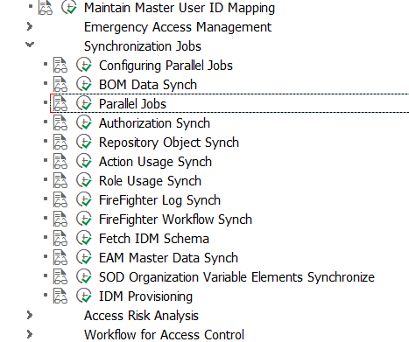

Programs for the Sync Jobs:
SE38 ----- > GRAC*SYNC*

